**EXCEL ASSIGNMENT – 7**

1. Using Insert Function, give examples of any function available in the different dropdowns present in the function library. For example AutoSum, Recently Used, Text, Date & Time, etc.

To insert a function from the Function Library:

1. Select the cell where the answer will appear (**I6**, for example).
2. Click the **Formulas**tab.
3. From the **Function Library** group, select the **function category** you want. In this example, we'll choose **Date & Time**.
4. Select the desired **function**from the Date & Time drop-down menu. We'll choose the **NETWORKDAYS** function to count the days between the order date and receive date in our worksheet.

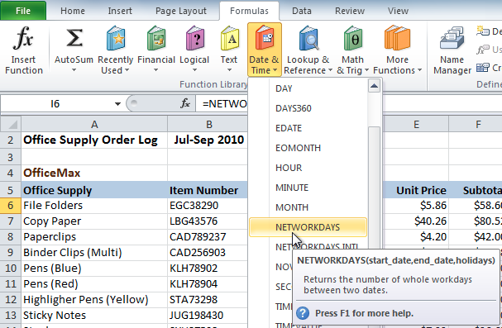

1. The **Function Arguments** dialog box will appear. Insert the cursor in the **first field**, then enter or select the cell(s) you want (**G6**, for example).

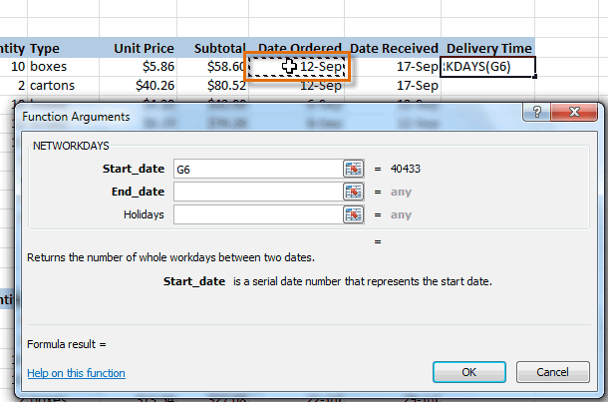

1. Insert the cursor in the **next field**, then enter or select the cell(s) you want (**H6**, for example).

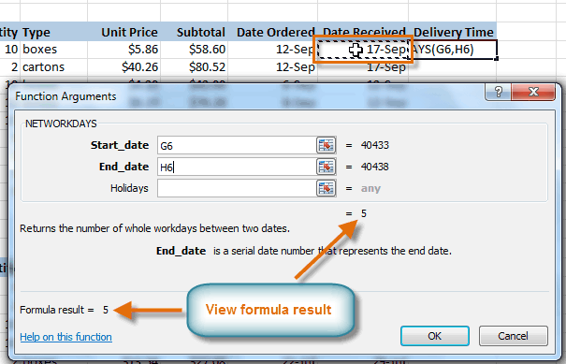

**Click OK, and the result will appear. Our results show that it took five days to receive the order.**

2. What are the different ways you can select columns and rows?

1. Select the letter at the top to select the entire column. Or click on any cell in the column and then press Ctrl + Space.
2. Select the row number to select the entire row. Or click on any cell in the row and then press Shift + Space.
3. To select non-adjacent rows or columns, hold Ctrl and select the row or column numbers.

3. What is AutoFit and why do we use it?

Excel's AutoFit feature is designed to automatically resize cells in a worksheet to accommodate different sized data without having to manually change the column width and row height. AutoFit Column Width - changes the column width to hold the largest value in the column.

4. How can you insert new rows and columns into the existing table?

To insert a row, pick a cell or row that's not the header row, and right-click. To insert a column, pick any cell in the table and right-click. Point to Insert, and pick Table Rows Above to insert a new row, or Table Columns to the Left to insert a new column.

OR we can use the following shortcut keys:

ALT+H 🡪ALT+I 🡪 I

5. How do you hide and unhide columns in excel?

On the Home tab, in the Cells group, click Format. Do one of the following: Under Visibility, click Hide & Unhide, and then click Unhide Rows or Unhide Columns.

6. Create an appropriate table within the worksheet and use different functions available in the AutoSum command.

